

**JOMO KENYATTA UNIVERSITY OF AGRICULTURE AND TECHNOLOGY**

**SCHOOL OF ELECTRICAL, ELECTRONIC AND INFORMATION ENGINEERING**

**DEPARTMENT OF ELECTRICAL & ELECTRONIC ENGINEERING**

**FINAL YEAR PROJECT PROPOSAL**

**PROJECT TITLE: IOT BASED ELECTRONIC VOTING SYSTEM**

**Submitted by:**

**KIGOKO ESTHER WANJIRA - ENE212-0063/2017**

**Project Supervisor:**

**MR. LINUS ALOO**

*A Final Year Project Proposal submitted to the Department of Electrical and*

*Electronic Engineering in partial fulfillment of the requirements for the award of a*

*Bachelor of Science Degree in Electronic and Computer Engineering.*

# DECLARATION

This project proposal is my original work, except where due acknowledgement is made in the text, and to the best of my knowledge has not been previously submitted to Jomo Kenyatta University of Agriculture and Technology or any other institution for the award of a degree or diploma.

NAME.………………………………………………………………………………….

SIGNATURE..…………………………………………DATE………………………

**SUPERVISOR CONFIRMATION:**

This project proposal has been submitted to the Department of Electrical and Electronic Engineering, Jomo Kenyatta University of Agriculture and Technology, with my approval as the supervisor:

NAME…………………………………………………………………………………

SIGNATURE..…………………………………………DATE………………………

ACKNOWLEDGEMENT

I acknowledge and appreciate the great commitment and support of my supervisor Mr Linus Aloo. I also appreciate the efforts and support of my classmates, family and friends, who took the time to correct, counsel, and encourage me during the development of this proposal.

# ABSTRACT

In recent years, traditional manual voting systems have been complemented or replaced by electronic voting systems which utilize various automation technologies in voting processes such as voter registration, identification, tallying, tabulating, and visualization of election results. E-Voting assures secure, efficient, and reliable elections, to resolve several challenges that manual voting systems have established, such as long lines at polling stations, low participation rates, inaccurate voter registration, irregular and time-consuming tallying, and delayed voting procedures.

The goal of this project is to develop and implement a functioning, transparent, and reliable electronic voting system to address the plethora of difficulties that have arisen primarily because of the in-use voting systems in Kenya. The project will entail an E-Voting system that uses an Electronic Voting Machine and a Web Application that provides an easy-to-use interface for in-house and remote voting respectively. All components of the E-Voting systems will be connected to a database management server that will deliver dynamic data to the client applications. In the use of the web application system for remote voters, a voter will be authenticated using a password and authorized to vote once. The use of electronic voting machine for in-house voters will require that a voter be authenticated using biometric scanning and authorized to vote once. The voter’s identity for both systems will be flagged after voting to prevent another attempt to vote. The system will use a secure MySQL database to manage the election data, as well as monitor system logins. Data will securely transferred to the database servers, and encrypted using data-at rest to reinforce data protection, guaranteeing that only authorized individuals can have access to the information after voters make their choices.

This electronic voting system guarantees security, convenience, and the integrity of an election. The proposed E-Voting system will complement the current voting system used in Kenya’s general elections and leverage security mechanisms that address the problems in the implemented manual voting systems.

# List of Figures

*Figure 2.*1 *: DRE Machine used in Brazil* 7

*Figure* 2 *.2: Mobile Voting* 9

*Figure 2.*3 *: Estonian Internet Voting architecture* 10

*Figure 2.4: U-Vote System Architecture......................................................................11*

*Figure 2.5: Biometric e-voting system.........................................................................12*

*Figure 2.6 Fingerprint Scanner...................................................................................14*

*Figure 2.7 Raspberry Pi Control Unit.........................................................................15*

*Figure 2.8 Raspberry Pi Touch Screen........................................................................16*

*Figure 2.9 Male to Female Jumper Wires...................................................................16*

*Figure 2.10 USB to TTL Serial Adapter......................................................................17*

*Figure 2.11 Raspberry Pi Power Supply.....................................................................17*

*Figure 3.12 System Methodology.................................................................................18*

*Figure 3.13 Project Block Diagram.............................................................................20*

*Figure 3.14 System Implementation Flowchart...........................................................21*

# List of Tables

*Table 6.1: Project Time Plan……………………………………………………………..…25*

*Table 6.2: Budget……………………………………………………………………………..26*

# **List of Abbreviations**

|  |  |
| --- | --- |
| API | Application Programming Interface |
| DRE | Direct Recording Electronic |
| EVM | Electronic Voting Machine |
| E-Voting | Electronic Voting |
| EVID | Electronic Voter Identification |
| ID | Identification |
| IDE | Integrated Development Environment |
| IDEA | Institute for Democracy and Electoral Assistance |
| IEBC | Independent Electoral and Boundaries Commission |
| JS | JavaScript |
| LCD | Liquid Crystal Display |
| LED | Light Emitting Diode |
| OMR | Optical Mark Recognition |
| PCOS | Precinct Count Optical Counting |
| PIN | Private Identification Number |
| REST | Representational state transfer |
| UI | User Interface |
| URL | Uniform Resource Locator |
| VVPAT | Voter Verifiable Paper Audit Trail |

**TABLE OF CONTENTS**

DECLARATION ii

ACKNOWLEDGEMENT iii

ABSTRACT iv

List of Figures v

List of Tables vi

List of Abbreviations vii

CHAPTER ONE: INTRODUCTION 1

1. Background Information 1

1.1 Problem Statement 2

1.2 Problem Justification 2

1.3 Objectives 3

1.3.1 Main Objective 3

1.3.2 Specific Objectives 3

1.4 Scope and Limitation 3

CHAPTER TWO: LITERATURE REVIEW 5

2.1 Introduction 5

2.2 Concept of Electronic Voting 5

2.3 Existing E-Voting Systems 6

2.3.1 E-Voting Typologies 6

2.3.2 E-Voting Systems and Related Works 10

2.4 Challenges in E-Voting 13

2.4 Components 14

2.4.1 Hardware Tools 14

CHAPTER THREE: METHODOLOGY 18

3.1 Introduction 18

3.2 Research Analysis and Design 18

3.2.1 Analysis 18

3.2.2 System Requirements 18

3.2.3 System Design 19

3.3 System Development Tools and Techniques 21

3.3.1 Hardware Tools 21

3.3.2 Software Tools 22

3.4 Functional and Non-Functional Requirements 22

3.4.1 Functional requirements 22

3.4.2 Non-Functional Requirements 22

3.5 Deliverables 22

3.5.1 Electronic Voting Machine prototype 22

3.5.2 Web Application Interfaces 23

CHAPTER 4: EXPECTED RESULTS 24

CHAPTER 5: PROJECT TIME PLAN 25

CHAPTER SIX: BUDGET 26

REFERENCES 27

# **CHAPTER ONE: INTRODUCTION**

## **Background Information**

Decisions must be made among different options in any democratic society by people with contradictory ideas and preferences. This happens in corporate and educational institutions, social organisations, and, most notably, in government. Voting is one of the methods for making such a decision: it is a formal process for individuals to express their support or opposition to a proposition of leadership and or a policy [1]. Today, systems and processes are increasingly being digitised because of technological innovations, conventional manual voting systems are becoming impractical. Traditional manual voting systems have been replaced by electronic voting (E-voting) systems owing to several challenges that manual voting systems have brought up, including long lines at polling stations, low participation rate, inaccurate voter registration, irregular and time-consuming tallying, and delayed voting procedure [2].

Electronic Voting generally refers to the automation of electronic voting and electronic counting processes which can use numerous technologies, including e-voter biometric registration, internet voting, e-counting etc [2]. The voter's vote is recorded by an electronic device. An electronic device is also used to count the ballots cast which could either be paper ballots or electronic ballots. It is possible to use e-voting and counting in combination with a manual system. However, in a fully implemented electronic voting solution, an electronic voting machine (remote or non-remote) directly records vote through a ballot user interface, electronically counts the votes cast and presents the results to parties involved in the elections [6].

A great number of developing countries have their elections conducted solely by traditional methods of voting, in contrast to most developed countries that have adopted E-voting systems [2]. Adopted electronic voting systems include Biometric Voter Registration, Smart card voting applied in Estonia, OMR ballots for Voting in the United States, and Direct Recording Electronic (DRE) voting.

Electronic voting systems have numerous strengths compared to manual voting systems. Electronic voting is better at fraud prevention. It reduces the chances of accidental or intentional variations in vote counts by reducing poll worker direct interaction with ballots or counts. Electronic voting also reduces voter errors and the chances of voter fraud, increasing electoral integrity. Additionally, results come in faster with electronic voting. With traditional paper methods, ballots must be collected and counted from polling stations. This process is time-consuming and delays the final result. To calculate the final result, all the polling stations report their votes and they're all added together. By using e-voting, the results of elections could be available in a matter of hours rather than days, meaning elections could have a more instantaneous impact. Furthermore, electronic voting is more accessible, allowing people who cannot reach polling stations to vote. People with disabilities are able to vote thanks to features like sip-and-puff voting, paddle voting, high-contrast viewing screens and audio voting. Currently, someone unable to mark paper ballots requires an assistant to vote for them. This process compromises the person's right to cast an anonymous ballot.

Therefore, when electronic voting is correctly planned and implemented, it can improve the reliability of election systems by securing votes cast, maintaining voter anonymity, and increasing voter convenience and flexibility.

## **Problem Statement**

Currently implemented manual and e-voting systems attribute to election irregularities such as vote count manipulation, polling station inaccessibility and ballot stuffing, errors in voter verifiability and vote auditing, lack of transparency and internal corruption. These irregularities incur damage to democratic societies causing a lack of confidence in democratic processes, political tension and confrontations by political parties and their supporters.

## **Problem Justification**

The e-voting system is developed using current technologies to provide an easy to follow, credible and transparent process in the voting process often marred by the multiple issues brought by the paper-based voting method and partial electronic voting systems. The system attempts to serve as a model for the IEBC and institutions that undertake the voting process, to implement a viable E-Voting system.

The system is important because it ensures that voters are registered accurately, and they can vote easily, and conveniently. The system aims to also lower the cost and provide an environmentally friendly alternative to the paper-based voting method. Additionally, it will be able to successfully manage the election results securely and transparently. The system is also significant since it aims to increase voter participation by providing an easy and more convenient way to approach the voting process.

This project will contribute research and design knowledge on the implementation of an electronic voting system. It will also serve as a hands-on application of concepts taught in class in communications technologies, database management, software, and hardware development; as well as a potential learning curve for me.

## **Objectives**

### **Main Objective**

To design and implement a functioning, transparent, verifiable, and reliable electronic voting system that mitigates the myriad of issues that exist predominantly due to the currently used voting systems.

### **Specific Objectives**

1. To design and create a web-application for electronic voting and visualisation of election results.
2. To interface a web-application and biometric scanner to a microcontroller for electronic voting.
3. To design and create a database for storing voter information.
4. To create a prototype of the project and test the electronic voting system.

## **Scope and Limitation**

This project will combat electoral irregularities of existing voting systems, particularly in Kenya and provide benefits of using electronic voting technologies such as increased efficiency, flexibility, and fewer costs by developing and implementing an E-Voting system that assures security, transparency, and integrity of the voting processes.

There is limited research material on electronic voting in Kenya. However, to address this problem I will rely on using research material by William Magonga [7] and research materials on e-voting in other countries such as Brazil, France, Estonia, Namibia etc.

# **CHAPTER TWO: LITERATURE REVIEW**

## **2.1 Introduction**

This chapter presents and analyses recent literature on electronic voting, as a theoretical overview of electronic voting and highlights relevant information on current e-voting systems. It concludes with a conceptual framework of the proposed electronic voting system.

## **2.2 Concept of Electronic Voting**

Electronic voting systems employ information and communication technology to record, cast, or count votes in political elections and referendums [8]. Electronic voting can either be fully electronic or partially electronic [9]. A fully automated electronic voting system can be remote or not, it records a vote through an electronic interface ballot, electronically counts votes cast and delivers the results by the use of an interface.

Any electronic voting system must meet the fundamental election standards that apply to every voting system to ensure free and fair elections [10]. These fundamental election standards include:

1. Eligible voters should be authenticated and authorised.
2. Votes should be accurately recorded and counted.
3. A voter should be able to cast a secret ballot that is receipt free.
4. Vote integrity and security should be upheld through verification and auditing.
5. The voting system should be reliable, flexible and robust.
6. Voting systems should be convenient to voters and cost-effective to the electoral body.
7. Voting systems should be secure.

However, electronic voting systems have system-specific election requirements that ensure the system works seamlessly including, ease of accessibility, availability of the system to provide multi-user and multi-elections capabilities [10].

## **2.3 Existing E-Voting Systems**

Electronic voting methods are being adopted around the world for different types of elections such as national elections, parliamentary elections, school elections and corporate elections. Several countries across the world have adopted the use of e-voting systems fully and partially to exercise democracy, they include India, France, Estonia, Brazil, Switzerland, Belgium, Namibia, the United States among others.

However, other countries are headed in the opposite direction. After decades of electronic voting, the Netherlands decertified its e-voting equipment and moved back to paper ballots in 2008. Similarly, Germany recently banned the use of their electronic voting machines. Moreover, e-voting technologies such as internet voting in the United States are controversial and hamper the absolute adoption of e-voting [9].

### **2.3.1 E-Voting Typologies**

Different E-voting models are currently being used in several governments and institutions meeting the generic and system-specific system requirements to provide fair and credible elections. When compared to one other and traditional paper-based voting, each E-Voting typology has its own set of merits and demerits.

#### **2.3.1.1 E-Voting Machines (EVM)**

E-voting technology, such as E-voting machines, have been deployed to ensure that voting and counting procedures are automated and transparent. Electronic voting machines (EVMs) are electromechanical or electronic devices that can be used to define ballots, cast and/or count votes, record, and display election results, and/or retain and provide audit trail data [3].

1. **Direct-recording electronic voting machine (DRE)**

A DRE is an electronic voting machine that allows voters to record their ballot choices directly using a keyboard, touch screen, mouse, pen, or other electronic devices. DRE's are used in supervised locations such as polling stations. Before voting, some DRE machines need voters to insert an access card, while others require an electronic ballot, biometrics, or an access code for authentication. Once a vote makes their choice it records and stores the votes.  Each DRE unit's data is then communicated either electronically (through the Internet, memory card or a cellular network) or manually. Several countries, including India, the Netherlands, and Brazil, have employed DRE machines [3].

Brazil adopted E-Voting to combat fraud in the paper ballot tabulation process and was the first country to conduct elections entirely using electronic voting in 2000, and it has been at the frontline of the electronic voting revolution by use of DRE [11]. DREs in Brazil are used for voter identification, voting, counting, and auditing. DRE used in Brazil greatly speeds up the vote count and helps to avoid fraud.

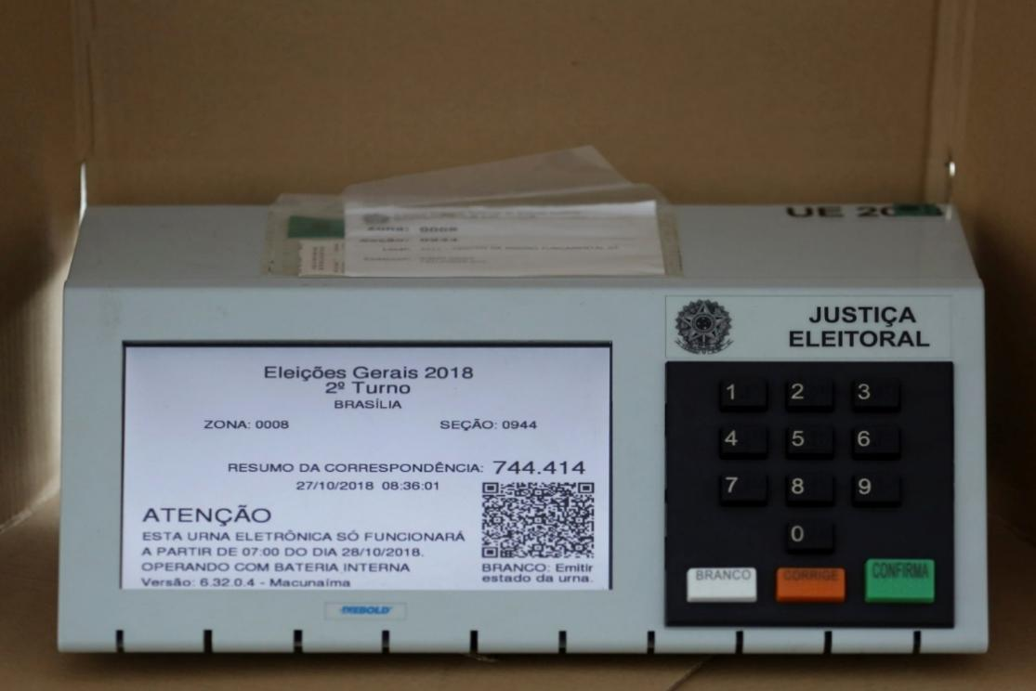

*Figure 2.1**: DRE Machine used in Brazil*

In France, electronic voting machines were initially used in the 2007 presidential elections, and they are now being used in general elections. The 2007 elections featured an all-time high voter turnout of 85%. EVMs have been used in subsequent elections since then, ahead of the 2022 France presidential elections, electronic voting machines will be used to vote [12].

1. **EVM VVPAT (Voter Verifiable Paper Audit Trail)**

A voter-verified paper audit trail is an optional feature of a DRE, where a VVPAT device is attached to an EVM and serves as an independent verification system for voters to ensure that their vote is appropriately recorded on a paper record by printing the voter record. In EVM VVPAT the primary source for the count is the electronic record of the vote, however, the printed paper can be utilised to detect probable election fraud or machine failure, as well as audit the stored electronic results. VVPAT is being employed on a small scale in various places in the United States and India. VVPAT was also used in the recent Namibian elections [3].

In India, the Indian Supreme Court ascertained that a traceable paper trail is required for voter trust in the system. Consequently, there is the use of VVPAT system in India that generates a paper slip with the candidate's serial number, name, and symbol for whom the vote was cast through a glass, the voter views the paper slip for five seconds and is sliced and deposited into a box that is permanently linked to the printer.

Namibia became the first African country to use electronic voting in a national election in 2014. The Namibian Electoral Act of 2014 allowed for electronic voting, but it also required that the use of voting machines would be coupled with the use of a verifiable paper trail for confirmation and audit purposes [9].

1. **Paper Ballot with Optical Mark Recognition**

OMR systems are based on scanners that can read specific machine-readable ballot sheets and verify the voters' choices. OMR systems can be either central where ballot papers are scanned and counted in a customised counting mechanism or by use of optical scanning in polling stations using precinct count optical scanning (PCOS) systems where scanning is done in precincts as in the United States [8].

#### **2.3.1.2 Internet Voting**

Internet voting systems, in which voters cast are sent to a central server via the Internet for tallying. Votes can be cast from either a personal computer at a remote unsupervised place or voting kiosks in polling stations equipped with an Internet-connected mobile device or computer. Several countries such as Canada, Estonia, the United States, India, Switzerland, and Norway have adopted internet voting.

* 1. **Mobile Voting**

Mobile voting is a method of internet voting that incorporates the use of mobile devices such as phones, tablets, and personal digital assistants to cast ballots remotely in an unsupervised location primarily using a cellular network and vote tallying done via computer systems [13]. Mobile voting is an electronic voting system that eliminates the inherited restrictions of traditional and some e-voting systems, which in many cases required individuals and polling officials to be physically present at the polling station [6].

*Figure 2**.2: Mobile Voting*

* 1. **Internet Voting with Cryptographic Encryption**

Internet Voting in Estonia employs the use of Pallier’s homomorphic cryptography encryption for security. The use of smart cards, electronic signatures, and cryptographic tallying are utilised to provide secure remote internet voting to their voters. Voter authentication is done by use of a Digital ID, Mobile ID, or ID card with PIN codes. In the 2015 Parliamentary elections, Estonian internet voters cast their votes by encrypting the candidate number which is ciphered and digitally signed. The ciphered votes are delivered to a Vote Forwarding Server (VFS) for verification and then delivered to the Vote Storage Server (VSS) for storage. A Vote Tallying Server and the Hardware Security Module (HSM) are used for vote extraction and tallying. [14].

*Figure 2.3**: Estonian Internet Voting architecture*

Internet Voting in Geneva, Switzerland employs the use of quantum cryptography. Voters are issued with voting cards with a quantum random voting card number (VCN) and password, control code, URL of the voting server and SSL certificate fingerprint for security. The voter is authenticated in the E-voting system using their VCN, password, date of birth and municipality of origin. Once logged in the system establishes an SSL/TLS connection which sends a Java applet from the voting server that is run and thereafter used for voting. A Diffie-Helman key exchange is performed to authenticate a user into the Java applet. Subsequently, the voter casts their vote, and the applet sends it to the server after validating the parameters. Once the electoral register verifies the validity of the parameters, the server encrypts the VCN and the vote for tallying [16].

### **2.3.2 E-Voting Systems and Related Works**

#### **2.3.2.1 U-Vote E-Voting System**

Some researchers have designed and developed U-Vote as a ubiquitous, secure, reliable, and verifiable e-voting system [17]. The system is implemented by a convenient front-end (UI) system that complements traditional voting systems using them as a backend to enhance the system from security attacks and allow remote voting. U-Vote allows voters to cast their votes using different devices such as computers and mobile phones and communication technologies e.g., Internet and cellular networks. It also allows voter verifiability by enabling a voter to verify the recorded choices before and after submitting the vote. U-Vote system security by effectively handling malware attacks, man-in-the-middle-attacks, voter selling and voter authentication hacking [17].

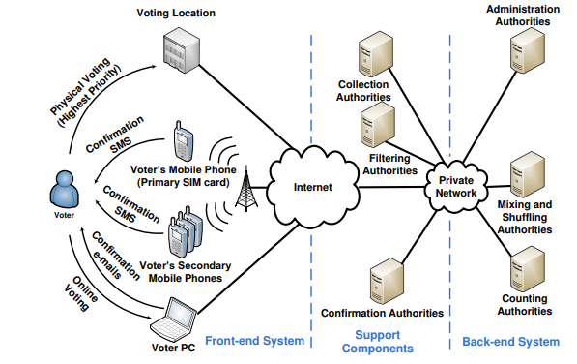

*Figure 2.4: U-Vote System Architecture*

#### **2.3.2.2 Smartmatic E-Voting System**

This is a multi-user and multi-elections commercial system that has been developed by Smartmatic election solutions that aim to provide secure, seamless, accessible, and transparent elections. The system has been in use for 7 elections across 6 countries including the Philippines and Venezuela. It allows for remote and non-remote voting by providing necessary infrastructure such as DREs and internet voting to facilitate e-voting. Voter authentication is provided through biometric voter identification using fingerprints and votes are encrypted. Smartmatic e-voting system also provides e-counting, voter management and poll worker support. Security is enhanced in this system using multiple audits, voter-verifiable printed audit trails, the encrypted transmission of voter data and redundant storage [2].

#### **2.3.2.3 A Biometric-Secure E-Voting System**

Researchers proposed a multifaceted, multi-user, and multi-elections online e-voting system that provides transparency, integrity, robustness, and security to the entire voting process [3]. The proposed system is a client/server web-enabled software for e-voting with the server handling a global database of registered voters and candidates as well as backend statistics while the client-side handles a local dynamic database and the voting interface. Voters are authenticated through biometric fingerprint identification and the system performs identity matching using custom techniques thereafter to combat voter impersonation, voter identification using a voter’s card is performed. Transparency is achieved by either providing a voter-verifiable printed audit trail or producing an unidentifiable vote copy. Votes are sent to the server which tallies votes, the incorporation of system FLAG’s ensures vote tally correctness.

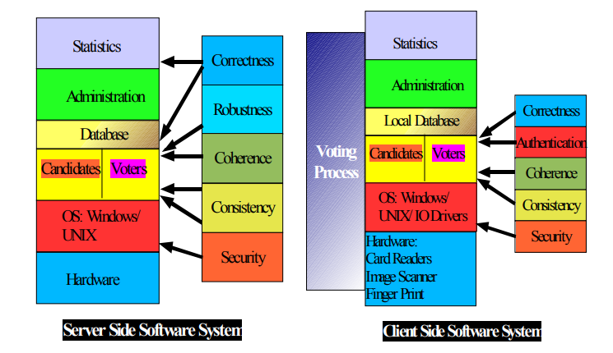

*Figure 2.5: Biometric e-voting system*

#### **2.3.2.4 Kenya’s Electronic Management System**

The current electronic election system in Kenya originates in 2007’s post-election violence, which prompted the Kriegler Commission to recommend an effective, transparent, and efficient voting system for Kenya [5]. From this, the IEBC implemented an election management system that included biometric voter registration and verification, identification, and an electronic results transmission system. In the 2013 elections, Biometric-based digital registers were added to the existing print versions of the election management system, printed voter's cards were ditched, and a digital layer was added to the physical tallying and aggregation of results. Biometric technology was employed for voter registration (Biometric Voter Registration – BVR) and Electronic Voter Identification (EVID), while text messaging service (SMS) was used for the Electronic Results Transmission System (RTS) [18]. For the 2017 General Elections, the system was improved in several ways, mainly by converging all technical pieces into one system, the Kenya Integrated Election Management System (KIEMS). Backup batteries were provided for hardware components, MSSQL Servers and web-service servers were deployed in place of static servers to manage high traffic to and from IEBC [18].

## **2.4 Challenges in E-Voting**

Researchers urge electoral bodies and administrators to implement measures to reduce operational costs and risks in carrying out elections [9]. Technology is a tool that can be utilised to aid in conducting efficient and precise elections by employing technology in voter registration, identification, tallying, tabulating and visualisation of election results. However, technological systems are prone to cyber-attacks that could impair the integrity of an election.

India has the largest voting population in the world and has adopted the use of EVMs after 22 years of testing by the electorate body in India. In 2009, the Election Commission of India stated publicly that the results were completely tamper-proof. Nonetheless, the findings of an academic investigation conducted by Indian and international experts revealed distinct vulnerabilities via physical and cyber-attacks [3]. Additionally, the findings state that inside officials who are probable attackers could use the EVMs to change votes stored in the machine’s memory.

Moreover, Brazilian DREs have been deemed more vulnerable to tampering and sophisticated fraud than any other voting method by Brazilian specialists. A lack of emphasis on security and a socially centred approach to technology in e-voting in Brazil poses a significant risk to democracy. As a result, e-voting in Brazil appears to exacerbate the digital divide [19].

In Kenya, during the 2013 elections, large portions of the EVID systems failed, requiring election authorities to rely on manual systems. Due to these failures, the losing party claimed that the election was rigged, and that the technology failure was purposeful, allowing results to be digitally altered through vulnerabilities in the manual system [18]. On 9th August 2017, the opposition released a press statement which backed non-substantial and mysteriously acquired server log files. According to a statement issued on election day, unknown hackers used the credentials of a deceased IEBC's ICT manager to gain access to the commission's computer system, where they allegedly "installed an algorithm" that allowed them to tamper with the results being broadcast from tallying centres across the country [18].

Remote internet voting makes e-voting systems vulnerable to internal corruption and hacking using cyber-attacks like malware, denial of service attacks and voter anonymization [14]. Remote internet voting also hinders election authorities and administrators to conduct audits of election results or reliably detecting errors or manipulation in the vote casting.

Internet Voting in France is used by diaspora voters in a bid to ensure high voter participation and this has been in practice since 2006. Recently, the Ministry of Europe and Foreign Affairs approved a new Internet-voting platform for the May 2020 French consular elections, allowing that French residents living abroad will be able to vote in person, by internet voting or by proxy[20]. However, this system of internet voting has been prone to errors in voter verifiability and vote auditing, this has in turn caused loss of confidence in results by voters and political parties.

## **2.4 Components**

The following software and hardware components will be interfaced to create a functioning model of the electronic voting system.

### **2.4.1 Hardware Tools**

**2.4.1.1 R305 Fingerprint Scanner Sensor Module**

The fingerprint scanner provides an authentication resource by scanning and matching. The adafruit fingerprint scanner has four pins, two of which are used for serial TTL communication (the RX and TX), while the other two provides the power supply. The fingerprint sensor can be connected to the Raspberry Pi USB port through a TTL-USB converter powers the scanner with 5V. The fingerprint sensor working is controlled by a program.

*Figure 2.6 Fingerprint Scanner*

**2.4.1.2 Raspberry Pi 4**

Raspberry Pi is a series of small [single-board computers](https://en.wikipedia.org/wiki/Single-board_computer" \o "Single-board computer) (SBCs). It has a 1.5 GHz 64-bit quad core [ARM Cortex-A72](https://en.wikipedia.org/wiki/ARM_Cortex-A72" \o "ARM Cortex-A72) processor, on-board 802.11ac [Wi-Fi](https://en.wikipedia.org/wiki/Wi-Fi" \o "Wi-Fi), [Bluetooth 5](https://en.wikipedia.org/wiki/Bluetooth_5" \o "Bluetooth 5), full [gigabit Ethernet](https://en.wikipedia.org/wiki/Gigabit_Ethernet" \o "Gigabit Ethernet) (throughput not limited), two [USB 2.0](https://en.wikipedia.org/wiki/USB_2.0" \o "USB 2.0) ports, two [USB 3.0](https://en.wikipedia.org/wiki/USB_3.0" \o "USB 3.0) ports, 1–8 GB of RAM, and dual-monitor support via a pair of micro HDMI ([HDMI Type D](https://en.wikipedia.org/wiki/Mini-HDMI" \o "Mini-HDMI)) ports for up to [4K resolution](https://en.wikipedia.org/wiki/4K_resolution" \o "4K resolution).. The Pi 4 is also powered via a [USB-C](https://en.wikipedia.org/wiki/USB-C" \o "USB-C) port, enabling additional power to be provided to downstream peripherals, when used with an appropriate PSU.

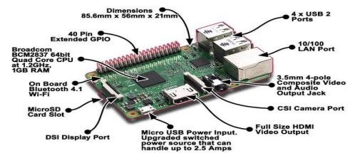

*Figure 2.7 Raspberry Pi Control Unit*

**2.4.1.3 Raspberry Pi Touch Display**

Adding a display to one’s Raspberry Pi can give projects new exciting interfaces, increased mobility and save a significant amount of space. [It allows the user to add touch inputs](https://thepihut.com/products/official-raspberry-pi-7-touchscreen-display) to programs, creating a new way to interact with projects. It is powered directly by the Raspberry Pi GPIO pins for display and directly communicates with the Raspbian operating system running on the Pi to enable input to the screen. The 3.5-inch capacitive touch screen has an impressive response time.

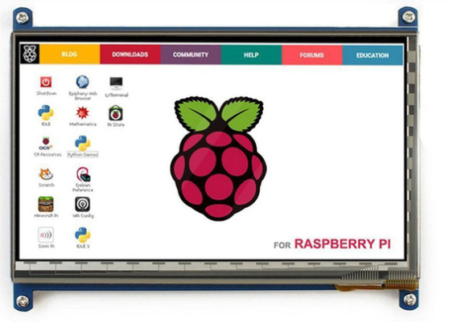

*Figure 2.8 Raspberry Pi Touch Screen*

**2.4.1.4 Jumper Wires male to female**

Jumper wires are wires that have connector pins at each end, allowing them to be used to connect two points to each other without soldering. Jumper wires are typically used with [breadboards](https://blog.sparkfuneducation.com/what-is-a-breadboard) and other prototyping tools in order to make it easy to change a circuit as needed.



*Figure 2.9 Male to Female Jumper Wires*

**2.4.1.5 USB to TTL Serial Adapter**

The USB TTL Serial cables are a range of USB to serial converter cables which provide connectivity between USB and serial UART interfaces. A range of cables are available offering connectivity at 5V, 3.3V or user specified signal levels with various connector interfaces. All cables feature an FTDI FT232R device integrated within the cable USB type ‘A’ connector, which provide access to UART Transmit (Tx), Receive (Rx), RTS#, CTS#, VCC (5V) and GND connections.

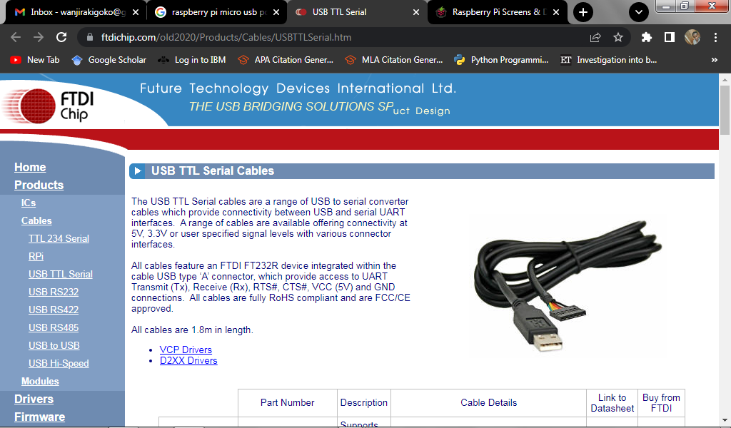

*Figure 2.10 USB to TTL Serial Adapter*

**2.4.1.6 Raspberry Pi 12.5W Micro USB Power Supply**

It provides power supply for all micro USB-powered Raspberry Pi computers. It has a 5.1V / 2.5A DC output and a 96-264Vac operating input range. It also has a short circuit and overcurrent protection. It has a 1.5m 18AWG captive cable with micro USB output connector and is available in different variants to suit different international power sockets



*Figure 2.11 Raspberry Pi Power Supply*

# **CHAPTER THREE: METHODOLOGY**

## **3.1 Introduction**

This chapter will describe the methodology techniques, procedures, and design tools to be utilized to achieve the project objectives. It also covers the requirements and deliverables of the e-voting system.

## **3.2 Research Analysis and Design**

### **3.2.1 Analysis**

The project technique will entail creating a working prototype for a website and a GUI interactive machine that guarantees voters are correctly registered and may vote easily and conveniently while maintaining the integrity of the voting processes. The prototyping is illustrated below:

*Figure 3.12 System Methodology*

### **3.2.2 System Requirements**

The first step in the prototyping model involves requirement gathering and analysis. In this first step, the requirements of the system were clearly defined. Additionally, the specifications of the input and output or the final prototype are identified.

The following are the requirements for the e-voting system that will be developed:

1. The E-Voting system consists of the following subsystems:

* An electronic voting machine prototype.
* A user interfaces for internet voting.
* A user interface for administrative tasks.
* A user interfaces for displaying the results.
* A secure server for election tallying and a database for data storage.

1. The electronic voting machine prototype should allow biometric voter registration and capture voter details into the secure database system.
2. The system should allow a user to verify their registration and authenticate a voter using their fingerprints and voter ID or one-time password and voter ID.
3. The software platform should be accessible to administrators and voters for management and voting respectively.
4. The system should securely transmit, store and tally votes in a secure database.
5. The software platform should be available to everyone for result visualization.

### **3.2.3 System Design**

This phase examined the requirements specifications from the previous phase and prepared the system design which will aid in describing hardware and system requirements. The system design will entail designing a prototype that interconnects components in the system to work together as depicted is divided into:

1. Hardware Design
2. Software Design

#### **3.2.3.1 Hardware Design**

The EVM prototype will be developed for biometric voter registration, Electronic Voter Identification (EVID) and voting. This will involve collecting voters’ biometric data and storing the data in the database through the server as well as identifying a voter and voting on the same machine. The prototype will be developed using a low-cost small computer connected to a fingerprint sensor for authentication that will send voter data.

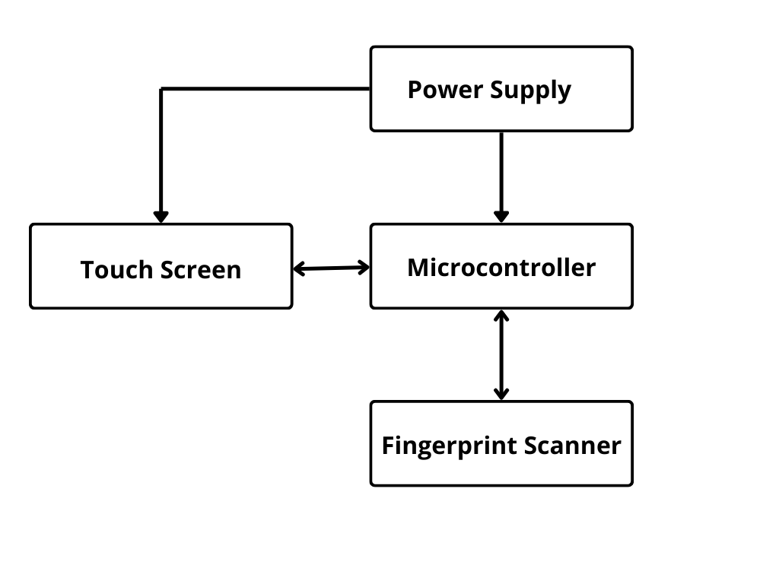

*Figure 3.13 Project Block Diagram*

#### **3.2.3.2 Software Design**

All the software platforms required for the system's operation and interaction in the prototype will be developed using an IDE on a personal computer. The user interfaces will be dynamic web applications developed to integrate the basic CRUD (Create, Read, Update and Delete) features for voting processes.

A MySQL Server database management system will be used to add, access, and process election data while providing relational mapping of data. The database will be secured using passwords and data-at-rest encryption in the database.

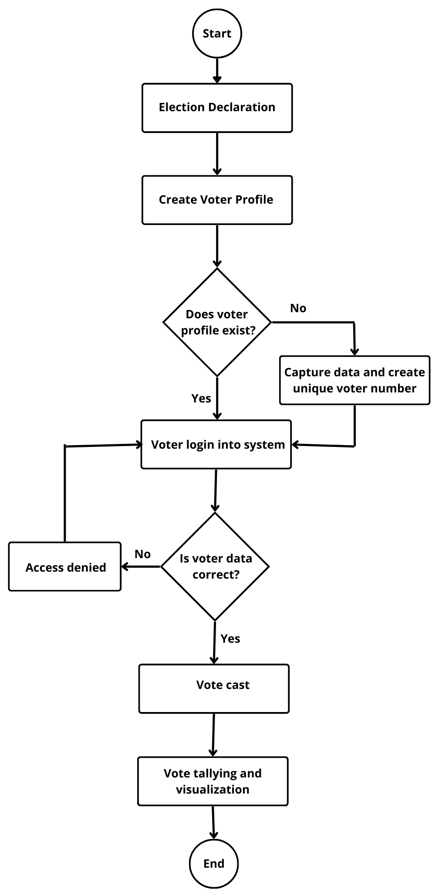

*Figure 3.14 System Implementation Flowchart*

## **3.3 System Development Tools and Techniques**

The following software and hardware components will be interfaced to create a functioning model of the electronic voting system.

### **3.3.1 Hardware Tools**

1. Fingerprint Scanner Sensor Module
2. Raspberry Pi 4
3. Raspberry Pi Touch Display
4. Jumper Wires male to female
5. USB to TTL Serial Adapter
6. Raspberry Pi 12.5W Micro USB Power Supply

### **3.3.2 Software Tools**

1. PyCharm IDE
2. MySQL Server Database
3. Python Libraries
4. Visual Studio Code IDE
5. Thonny Python IDE

## **3.4 Functional and Non-Functional Requirements**

### **3.4.1 Functional requirements**

The functional requirements include: the system should allow registered authorized voters to vote efficiently, in a single session, and with an easy-to-use user interface. Voters should only vote once during the voting period, and the system should allow them to double-check their vote before casting. In addition, the system should accurately authenticate, record, count, and audit all votes.

### **3.4.2 Non-Functional Requirements**

The non-functional requirements include: The system interfaces should present a friendly graphical interface to ensure ease of use and during the entire voting process, the system must operate at maximum efficiency.

## **3.5 Deliverables**

### **3.5.1 Electronic Voting Machine prototype**

An electronic voting machine prototype containing a fingerprint reader for authentication, as well as voting software and internet connectivity. This will be used for Biometric Voter Registration, Electronic Voter Identification (EVID), as well as voting.

### **3.5.2 Web Application Interfaces**

The web application user interfaces are used for accessibility of the voting process to administrators and remote voters for management and voting respectively, as well as for results visualization.

# **CHAPTER 4: EXPECTED RESULTS**

It is expected that the project will implement a function electronic voting system that will allow voters to cast their votes physically or remotely. The biometric scanner will be used to authenticate physical voters. Raspberry pi will help interface the biometric scanner and raspberry pi screen for online voting and displaying of election results. The web application will provide an easy to use interface for online voting. The raspberry pi screen will display the cumulative election results. It is further expected that:

1. The electronic voting machine prototype will allow biometric voter registration and capture voter details into the secure database system.
2. The system will allow a user to verify their registration and authenticate a voter using their fingerprints and voter ID or password and voter ID.
3. The software platform will be accessible to administrators and voters for management and voting respectively.
4. The system will securely transmit, store and tally votes in a secure database.
5. The software platform will be available to everyone for result visualization.

# **CHAPTER 5: PROJECT TIME PLAN**

|  |  |  |  |  |  |  |  |  |  |  |
| --- | --- | --- | --- | --- | --- | --- | --- | --- | --- | --- |
| **TASK** | **DURATION** | | | | | | | | | |
| **SEMESTER 1** | | | | **SEMESTER 2** | | | | | |
| **MAY** | **JUN** | **JUL** | **AUG** | **SEP** | | **OCT** | **NOV** | **DEC** | |
| Project concept submission for approval. |  |  |  |  |  | |  |  |  | |
| Proposal writing and submission. |  |  |  |  |  | |  |  |  | |
| Project proposal presentation. |  |  |  |  |  |  |  |  |  | |
| Project documentation. |  |  |  |  |  | |  |  |  | |
| Purchase of components. |  |  |  |  |  | |  |  |  | |
| Project implementation and testing. |  |  |  |  |  | |  |  |  | |
| Project demonstration and presentation. |  |  |  |  |  | |  |  |  |  |

*Table 5.1 Project Time Plan*

# CHAPTER SIX: BUDGET

|  |  |  |  |
| --- | --- | --- | --- |
| **ITEM** | **QUANTITY** | **PRICE PER UNIT** | **TOTAL PRICE** |
| Raspberry pi 4 | 1 | 8,000 | 8,000 |
| Raspberry pi touch display | 1 | 3,000 | 3,000 |
| R305 Fingerprint Scanner Sensor Module | 1 | 1,600 | 1,600 |
| USB to TTL serial adapter | 1 | 400 | 400 |
| Raspberry Pi Micro USB Power Supply | 1 | 1,000 | 1,000 |
| Jumper wires (Male to Female) | 1 set | 200 | 200 |
|  |  | **TOTAL COST** | 14,200 |

*Table 6.2: Budget*

# REFERENCES

[1]C. Houle, “Does Ethnic Voting Harm Democracy?,” *Democratization*, vol. 25, no. 5, pp. 824–842, Jan. 2018, doi: <10.1080/13510347.2017.1423055>.

[2]A. Ben Ayed, “A Conceptual Secure Blockchain Based Electronic Voting System,” *International Journal of Network Security & Its Applications*, vol. 9, no. 3, pp. 01–09, May 2017, doi: <10.5121/ijnsa.2017.9301>.

[3]O. Adewale, O. Boyinbode, and S. Adekunle, “A Review of Electronic Voting Systems: Strategy for a Novel,” *International Journal of Information Engineering and Electronic Business*, vol. 12, no. 1, pp. 19–29, 2020, doi: <10.5815/ijieeb.2020.01.03>.

[4]Daily Monitor, “Besigye’s Name Missing at Polling Station,” *Monitor*, Feb. 02, 2021. <https://www.monitor.co.ug/uganda/special-reports/elections/besigye-s-name-missing-at-polling-station-1486878> (accessed Jul. 13, 2022).

[5]Carter Center, “Kenya General and Presidential Elections,” Mar. 2018. Accessed: Jul. 13, 2022. [Online]. Available: <https://www.cartercenter.org/resources/pdfs/news/peace_publications/election_reports/kenya-2017-final-election-report.pdf>

[6]F. Alsolami, “TokenVote: Secured Electronic Voting System in the Cloud,” *International Journal of Advanced Computer Science and Applications*, vol. 9, no. 11, 2018, doi: <10.14569/ijacsa.2018.091183>.

[7]W. Magonga, “A Secure End to End Verifiable E-voting System Using Cryptography: A Case of Independent Electoral and Boundaries Commission of Kenya,” Strathmore University, 2019. [Online]. Available: <http://su-plus.strathmore.edu/handle/11071/6709>

[8]International IDEA, “Introducing Electronic Voting: Essential Considerations | International IDEA,” *International Institute for Democracy and Electoral Assistance*, 2021. <https://www.idea.int/sites/default/files/publications/introducing-electronic-voting.pdf>

[9]B. Goldsmith, “Common Electronic Voting and Counting Technologies,” *National Democratic Institute*, Nov. 25, 2020. <https://www.ndi.org/e-voting-guide/common-electronic-voting-and-counting-technologies> (accessed Jul. 13, 2022).

[10]M. Germann and U. Serdült, “Internet Voting and Turnout: Evidence from Switzerland,” *Electoral Studies*, vol. 47, no. Elsevier, pp. 1–12, Jun. 2017, doi: <10.1016/j.electstud.2017.03.001>.

[11]NDI, “The Rationale for E-voting in Brazil,” *National Democratic Institute*, Jan. 02, 2022. <https://www.ndi.org/e-voting-guide/examples/the-rationale-for-e-voting-in-brazil> (accessed Jul. 13, 2022).

[12]N. Pinault, “France Signals It May Try Out Early Electronic Voting,” *VOA*, Feb. 19, 2021. <https://www.voanews.com/a/europe_france-signals-it-may-try-out-early-electronic-voting/6202280.html> (accessed Jul. 13, 2022).

[13]G. Oando, H. Bii, and E. Milgo, “Developing an M-Voting System for Political Party Elections in Kenya,” *International Journal of Scientific and Research Publications (IJSRP)*, vol. 10, no. 8, pp. 392–399, Aug. 2020, doi: <10.29322/ijsrp.10.08.2020.p10447>.

[14]A. Parsovs, “Homomorphic Tallying for the Estonian Internet Voting System,” *IACR Cryptol*, pp. 776–787, 2017, Accessed: Jul. 13, 2022. [Online]. Available: <https://eprint.iacr.org/2016/776.pdf>

[15]P. Ehin, M. Solvak, J. Willemson, and P. Vinkel, “Internet Voting in Estonia 2005–2019: Evidence from Eleven Elections,” *Government Information Quarterly*, p. 101718, Jun. 2022, doi: <10.1016/j.giq.2022.101718>.

[16]R. Krimmer *et al.*, *Electronic Voting : 4th International Joint Conference, E-Vote-ID 2019, Bregenz, Austria, October 1-4, 2019, Proceedings*. Cham: Springer International Publishing, 2019.

[17]S. Risnanto, Y. Abd Rahim, K. Mahatma, A. Effendi, and H. Garnida, “U-Vote: Ubiquitous Voting Model For General Election in Global Pandemic,” *In 2020 14th International Conference on Telecommunication Systems, Services, and Applications (TSSA) IEEE*, pp. 1–5, Nov. 2020.

[18]E. Kinya, “Electoral Process in Kenya | Kenya Law,” *Kenya Law*, Aug. 01, 2017. <http://kenyalaw.org/kenyalawblog/electoral-process-in-kenya/> (accessed Jul. 13, 2022).

[19]D. F. Aranha and J. van de Graaf, “The Good, the Bad, and the Ugly: Two Decades of E-Voting in Brazil,” *IEEE Security & Privacy*, vol. 16, no. 6, pp. 22–30, Nov. 2018, doi: <10.1109/msec.2018.2875318>.

[20]France Diplomacy, “French citizens abroad – Approval of electronic voting for consular elections (15 Jan. 2020),” *France Diplomacy - Ministry for Europe and Foreign Affairs*, Jan. 15, 2020. <https://www.diplomatie.gouv.fr/en/the-ministry-and-its-network/news/2020/article/french-citizens-abroad-approval-of-electronic-voting-for-consular-elections-15> (accessed Jul. 13, 2022).